Independence Youth Wrestling Signups
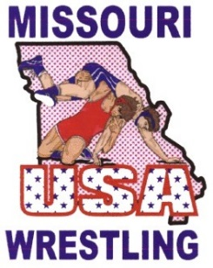
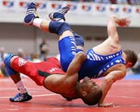
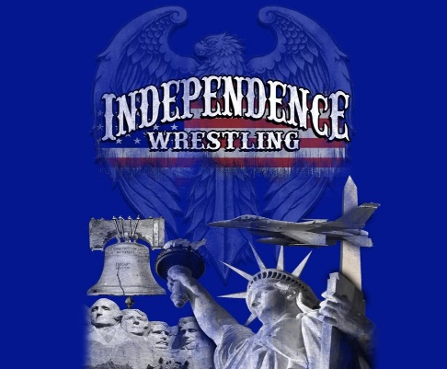

Jim Bridger Middle School Wrestling Room

Open sign-ups for our 2016-17 Season.
Open sign-ups for the 2016/17 season continue through December. The season runs from now through March 12, 2017
First Practice will be 11/2/2016 at Jim Bridger Middle School
- All kids 5 through 14 years of age are welcome.
- Participants will practice on Monday, Wednesday and Thursday
  - Practice times
    - 6:00 PM – 7:00 PM Wrestlers 8 and under.
    - 7:00 PM – 8:15 PM Wrestlers 9 and older.
- Tournaments are scheduled on Saturdays and Sundays, at local area schools.
- There are Novice tournaments for 1st and 2nd year wrestlers each weekend.
- Participation in all tournaments is optional, but encouraged. If you or your child has other obligations participation is not mandatory.
- There is an initial cost $110.00, this fee provides your wrestler with a USA Wrestling Card, singlet to us for the season, and team apparel.

For more information, visit www.independenceyouthwrestling.org or by calling:
Chuck Rodgers (816) 572-3463 or Bill Jones (816) 777-6794
cer.kct@att.net bjjones133@gmail.com
Sign-up Information

Wrestlers Name : ______________________ Gender: ____Male__ Age:_______

Parents Name: ___________________________ Phone: ____-____-________

Parents Email: ______________________________________________________________

Address: ______________________________________________________________

Shirt Size: ________________ Shoe Size: _________________

